**XAVIER INSTITUTE OF ENGINEERING**

**Department of Information Technology**

Class: BE IT Sem: VII A.Y :2022-2023

Course Name: Internet of Everything Lab

Group No. 18

|  |  |  |  |  |  |  |
| --- | --- | --- | --- | --- | --- | --- |
| **Chapter 1: Introduction to IoE** | | | | | | |
| ITL702.1. Identify the requirements for the real-world problems. | | | | | | |
| **Rubrics for Laboratory work** | | | | | | |
| **Roll No.** | **Name of the Student** | **Knowledge / Understanding (5)** | **Contents (4)** | **Presentation (4)** | **Punctuality & Lab ethics (2)** | **Total (15)** |
| 27 | Swaraj Jinagouda |  |  |  |  |  |
| 21 | Chris Gonsalves |  |  |  |  |  |
| 06 | Pratik Bhadane |  |  |  |  |  |
|  |  |  |  |  |  |  |

**CHAPTER 1**

**INTRODUCTION TO IoE**

* IoE is the intelligent connection between 4 key elements i.e. people, process, data, and things. It is considered as superset of Internet of Things (IOT).
* IoE covers the wider concept of connectivity where network intelligence works as the foundation of Internet of Things. Internet of Everything acts as an extension of Internet of Things.

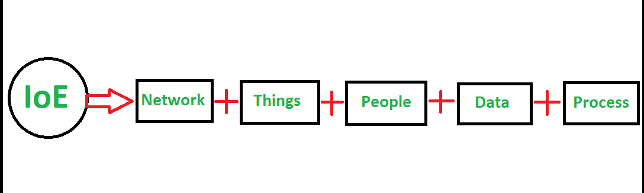

**Fig 1.a: Internet of Everything**

* IoT is a network of interconnected physical devices/objects which collects and exchange data over wireless networks. Internet of Things has two main parts i.e ‘Internet’ which is the backbone of connectivity and ‘Things’ meaning to object/physical devices.
* It brings the power of the internet, data processing and analytics and decision making to the real world of physical objects.

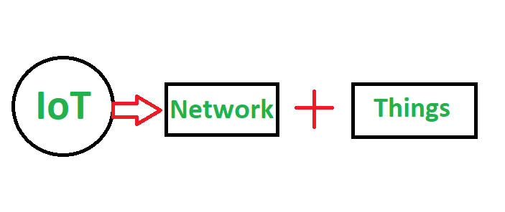

**Fig 1.b: Internet of Things**

**History of IoE**

* The actual idea of connected devices had been around since the 70s and was often called “embedded internet” or “pervasive computing”.
* But the actual term “Internet of Things” was coined by Kevin Ashton in 1999 during his work at Procter& Gamble. Ashton who was working in supply chain optimization, wanted to attract senior management’s attention to a new exciting technology called RFID.
* Because the internet was the hottest new trend in 1999 and because it somehow made sense, he called his presentation “Internet of Things”.
* Even though Kevin grabbed the interest of some P&G executives, the term Internet of Things did not get widespread attention for the next 10 years.
* The concept of IoT started to gain some popularity in the summer of 2010. Information leaked that Google’s StreetView service had not only made 360-degree pictures but had also stored tons of data of people’s Wi-Fi networks. People were debating whether this was the start of a new Google strategy to not only index the internet but also index the physical world.
* The term Internet of Things reached mass market awareness when in January 2014 Google announced to buy Nest for $3.2bn. At the same time the Consumer Electronics Show (CES) in Las Vegas was held under the theme of IoT.

**1.1 Working of IoE**

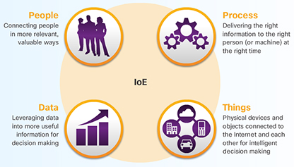

**Fig 1.1.a: Working of IoE**

The working of IoE depends on the four pillars of IoE which are

* People
* Process
* Data
* Things

**Things:**

* For the IoE to function, all of the devices that are part of the intended IoE solution must be connected together so that they can communicate.
* There are two ways in which devices can be connected; either wired or wirelessly. Devices that are not traditionally connected to the network require sensors, RFIDs, and controllers.

**Data:**

* Big Data refers to the vast amount of data generated every hour by billions of connected devices.
* Big Data requires new products and techniques to manage, store, and analyze it. Part of the solution to the problem of Big Data is virtualization and Cloud computing.
* Big Data refers to the way in which organizations collect and analyze vast stores of data for insights that can help identify trends, predict behavior, and empower decision makers.

**People:**

* Connected people make behavioural transformations based on their access to information.
* Simultaneously, their changed behaviour affects the information that is generated. This is known as a feedback loop.
* Organisations use data generated by connected people to refine and target their marketing strategies.

**Process:**

* Processes occur between people, things, and data. Today, the IoE brings them all together by combining M2M, M2P, and P2P connections.

**1.2** **REAL WORLD PROBLEMS AND THEIR IoT SOLUTIONS**

**a) Carbon footprint reduction:**

* There is no denying that we humans are accelerating the destruction of the planet. Fortunately, we are also smart beings that can find innovative ways to stop it.
* Smart things in your home, especially in your kitchen, will make it easier to go green. This is because IoT embedded kitchen appliances will make it easier to manage your energy consumption.

**Example:**

* We may start your morning with **smart Wi-Fi enabled coffee maker**. It can set coffee strength, cautions you if the water level is alarmingly low. We can control this gadget from Smarter Coffee from anyplace at home through your cell phone.
* Great ideas like **smart plugs** will also be able to intelligently detect household appliances that aren’t being used and turn them off while alerting the owner about the power that’s being consumed.

This means that we won’t have to worry about having left the iron on while we’re on our way to work ever again. The same applies to our toaster.

* Energy can also be saved by utilizing **smart thermostats** for temperature control which can turn on our heater or AC fifteen minutes before we get home or turn it off as soon as we head out the door.

**b) Security management:**

* Every company across all industries needs encryption and password management. Enterprises can be more secure with IoT as clothing with biometric sensing, facial recognition, and footprint identity can unlock doors and turn on lights without ever having to swipe a card (that can be easily lost).
* Furthermore, time cards can be punched automatically, stocks can be managed efficiently, and security can track your every move while on the premises. All of this will have a direct impact on employee productivity.

**c) Maintenance of equipment:**

* When something breaks at home or at work, we often have to obtain replacement parts. Now imagine the replacement parts arriving before an appliance even breaks?
* That’s what sensors in our devices can do when they recognize the wear and tear in aging parts that need repair. It’s already happening as printers can order replacement cartridges automatically from Amazon just before it runs out.
* By using this innovation, we can automate processes remotely. IoT can optimize the production processes and help to diagnose whether equipment requires repair or maintenance.

**d) Increasing yields and food supplies:**

* As the population continues to explode, there is an urgent need to find better ways to engage in agriculture. With the help of various governments, farmers are trying to achieve more yield with the help of IoT.
* The insights gained from all the collected data is helping farmers achieve a better yield on their ROI. IoT sensors monitor nutrients, soil moisture, and also control water usage. Further, growth is determined by custom fertilizer.

1.3 **APPLICATIONS OF IoE**

The applications of IoE technologies are multiple, because it is adjustable to almost any technology that is capable of providing relevant information about its own operation, about the performance of an activity and even about the environmental conditions that we need to monitor and control at a distance.

**1. Wearables**

* Virtual glasses, fitness bands to monitor for example calorie expenditure and heart beats, or GPS tracking belts, are just some examples of wearable devices that we have been using for some time now.
* Companies such as Google, Apple, Samsung and others have developed and introduced the Internet of Things and the application thereof into our daily lives.
* These are small and energy efficient devices, which are equipped with sensors, with the necessary hardware for measurements and readings, and with software to collect and organize data and information about users.

**2. Health**

* The use of wearables or sensors connected to patients, allows doctors to monitor a patient's condition outside the hospital and in real-time.
* Through continuously monitoring certain metrics and automatic alerts on their vital signs, the IoT helps to improve the care for patients and the prevention of lethal events in high-risk patients.
* Another use is the integration of IoT technology into hospital beds, giving way to smart beds, equipped with special sensors to observe vital signs, blood pressure, oximeter and body temperature, among others.

**3. Traffic monitoring**

* IoT can be very useful in the management of vehicular traffic in large cities, contributing to the concept of smart cities.
* When we use our mobile phones as sensors, which collect and share data from our vehicles through applications such as Waze or Google Maps, we are using the IoT to inform us and at the same time contribute to traffic monitoring, showing the conditions of the different routes, and feeding and improving the information on the different routes to the same destination, distance, estimated time of arrival.

**4. Fleet management**

* The installation of sensors in fleet vehicles helps to establish an effective interconnectivity between the vehicles and their managers as well as between the vehicles and their drivers.
* Both driver and manager/ owner can know all kinds of details about the status, operation and needs of the vehicle, just by accessing the software in charge of collecting, processing and organizing the data.
* Even, receive alarms in real time of maintenance incidents without having been detected by the driver.
* The application of the Internet of Things to fleet management assists with geolocation (and with it the monitoring of routes and identification of the most efficient routes), performance analysis, telemetry control and fuel savings.

**5. Agriculture**

* The quality of soil is crucial to produce good crops, and IoT offers farmers the possibility to access detailed knowledge and valuable information of their soil condition.
* Through the implementation of IoT sensors, a significant amount of data can be obtained on the state and stages of the soil.
* Information such as soil moisture, level of acidity, the presence of certain nutrients, temperature and many other chemical characteristics, helps farmers control irrigation, make water use more efficient, specify the best times to start sowing, and even discover the presence of diseases in plants and soil.

**6. Hospitality**

* The application of the IoT to the hotel industry brings with it interesting improvements in the quality of the service. With the implementation of electronic keys, which are sent directly to the mobile devices of each guest, it is possible to automate various interactions.
* Thus, the location of the guests, the sending of offers or information on activities of interest, the realization of orders to the room or room service , the automatic charge of accounts to the room or the request of personal hygiene supplies, are activities that can be easily managed through integrated applications using IoT technology.
* With the use of electronic keys, the check-out process is automated, disabling the operation of doors, offering information about the rooms immediately available, and even assigning housekeeping tasks to maintenance personnel.

**7. Water supply**

* A sensor, either incorporated or adjusted externally to water meters, connected to the Internet and accompanied by the necessary software , helps to collect, process and analyze data, which allows understanding the behavior of consumers, detecting faults in the supply service, report results and offer courses of action to the company that provides the service.
* Likewise, it offers final consumers the possibility of tracking their own consumption information, through a web page and in real time, even receiving automatic alerts in case of detecting consumption out of range to their average consumption record, which could indicate the presence of a leak.

**XAVIER INSTITUTE OF ENGINEERING**

**Department of Information Technology**

Class: BE IT Sem: VII A.Y: 2022-2023

Course Name: Internet of Everything Lab

Group No. 18

|  |  |  |  |  |  |  |
| --- | --- | --- | --- | --- | --- | --- |
| **Chapter 2: Introduction to Smart Trolley System using RFID** | | | | | | |
| ITL702.2. Conduct a survey of several available literatures in the preferred field of study. | | | | | | |
| **Rubrics for Laboratory work** | | | | | | |
| **Roll No.** | **Name of the Student** | **Knowledge / Understanding (5)** | **Contents (4)** | **Presentation (4)** | **Punctuality & Lab ethics (2)** | **Total (15)** |
| 27 | Swaraj Jinagouda |  |  |  |  |  |
| 21 | Chris Gonsalves |  |  |  |  |  |
| 06 | Pratik Bhadane |  |  |  |  |  |
|  |  |  |  |  |  |  |

**CHAPTER 2**

**INTRODUCTION TO SMART TROLLEY SYSTEM USING RFID**

**2.1 PROBLEM DEFINITION**

* Shopping is really fascinating and alluring; at the same time, it involves getting tired due to standing in a long queue for the bill and payment process.
* A huge crowd in the supermarket at the time of discount offers or weekends makes trouble to wait in long queues because of a barcode-based billing process.
* Our idea is to design a smart trolley which can take care of shopping and billing. By this, the customer can walk straightaway into the shop, purchase products using the smart trolley and walk out of the shop.
* They get the e-bill through a webpage, and they can view their purchased items details on the same webpage.

**2.2 AIM AND OBJECTIVES**

* The advent of wireless technology along with the other communication techniques help in making e-commerce very popular.
* Modern futuristic product is the one that aids the comfort, convenience and efficiency in everyday life. As it is rightly stated, "Necessity is the mother of invention", one can wish for less time-consuming and an effortless purchase would always opt for better technological support. In this project, we discuss an innovative concept of RFID Based Smart Shopping and Billing System.
* The main goal is to provide a technology oriented, low-cost, easily scalable, and rugged system for aiding shopping in person.
* The smart shopping trolley will help shorten the checkout lines thereby helping the customers at retail stores.
* This structure does not force customers to wait in queues for billing, alternatively, it helps in viewing the items they purchased through a webpage which helps them to make the invoicing process easier and more convenient.

**2.3 SCOPE OF PROJECT**

* Smart Cart with NodeMCU and RFID is a powerful device for product scanning, bill generation, and payment. It uses the RFID reader and the RFID tags of a NodeMCU, an LED, buzzers, and more.
* To scan the RFID tags present on the product and to store them in the NodeMCU, any information received from the tags is used by the RFID reader. The reader will scan the product directly and, if the consumer would like to remove some product, the product must be removed directly from the webpage.
* Complete bill is produced and shown on the webpage and the billing section after the purchase. The product is bought. The customer must only pay the sum when he goes to the billing area.
* The full list of products in the cart is shown on the webpage. The intelligent business using the trolley app states that an integrated and unified billing system can be created which can be used in shops and supermarkets.
* Since the total sum is generated on the webpage, customers need not stand by the billing counters to pay their bill, and the customer just has to pay at the billing counter.

**2.4 FEATURES OF THE PROJECT**

* After the purchase, a complete bill is generated and shown on the website and in the billing section. Only when he visits the billing area does the customer need to pay the total.
* An integrated and uniform billing system that can be utilized in stores and supermarkets, according to the intelligent business employing the trolley app, can be developed.
* Customers only need to pay at the billing counter because the amount is calculated on the website, eliminating the need for them to stand by the billing counters.
* An attractive and user-friendly website where the customer can increase or remove an added item and can also see the total payment amount of the purchased items.